3. CREATE A SIMPLE CLOUD SOFTWARE APPLICATION FOR PROPERTY BUYING & RENTAL PROCESS (IN CHENNAI CITY) USING ANY CLOUD SERVICE PROVIDER TO DEMONSTRATE SAAS.

DATE: 17.11.2025
DAY: MONDAY

AIM:
To Create a simple cloud software application for Property Buying & Rental process (In Chennai city) using any Cloud Service Provider to demonstrate SaaS.

PROCEDURE:
step1: Go to zoho.com.
step 2: Log into the zoho.com.
step 3: Select one application step.
step4: Enter application name as property buying & rental.
step 5: Created new application as property buying & rental.
step 6: Select one form
step 7: The software has been created.

IMPLEMENTATION:
1.Receiver Details
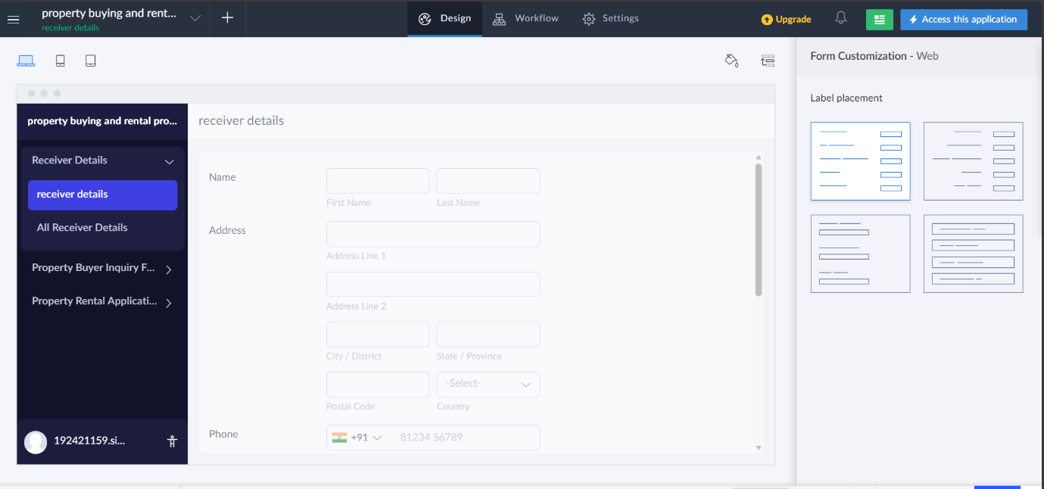

2.Property Buyer Enquiry
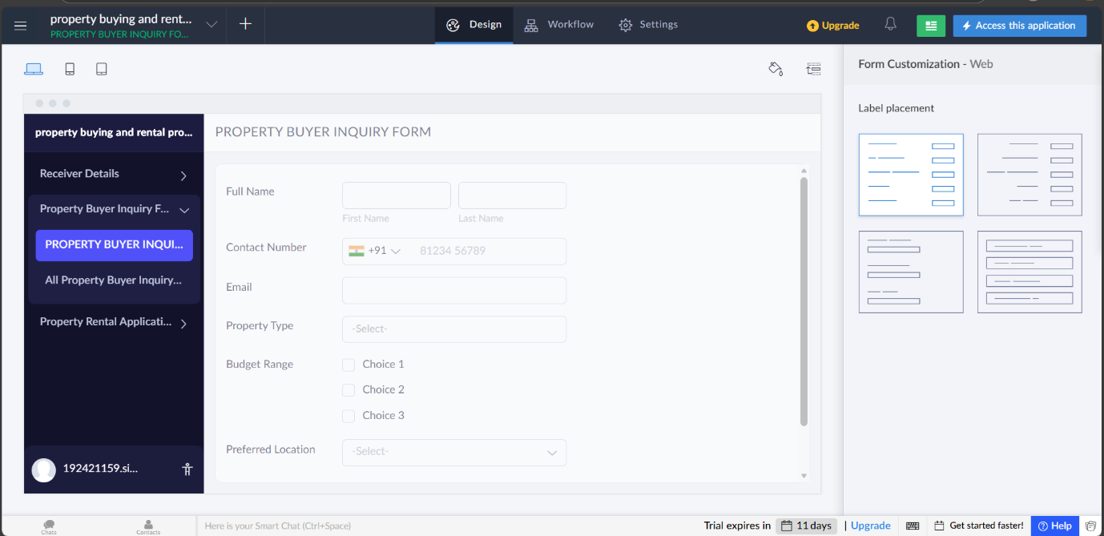

3.Property Rental Application Form
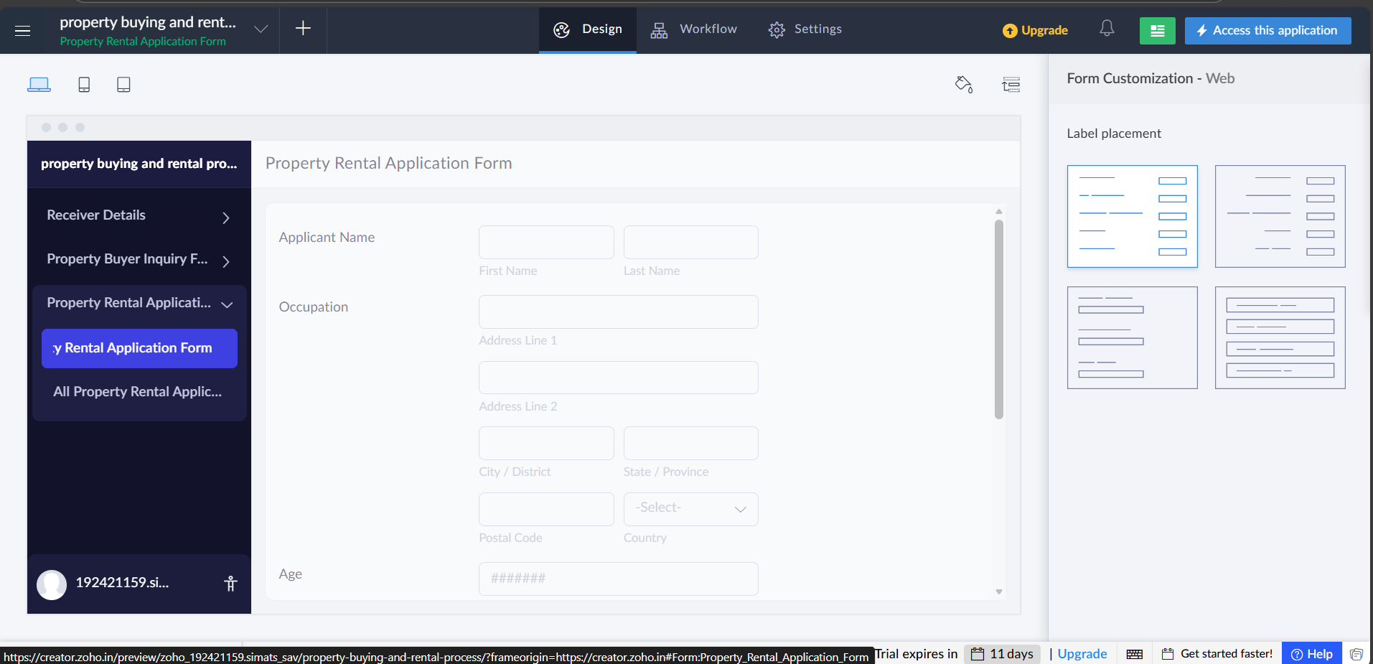

RESULT:
Successfully Created a simple cloud software application for PROPERTY BUYING AND RENTAL PROCESS

